For a binary tree **T**, we can define a **flip operation** as follows: choose any node, and swap the left and right child subtrees.

A binary tree **X** is *flip equivalent* to a binary tree **Y** if and only if we can make **X** equal to **Y** after some number of flip operations.

Given the roots of two binary trees root1 and root2, return true if the two trees are flip equivelent or false otherwise.

**Example 1:**

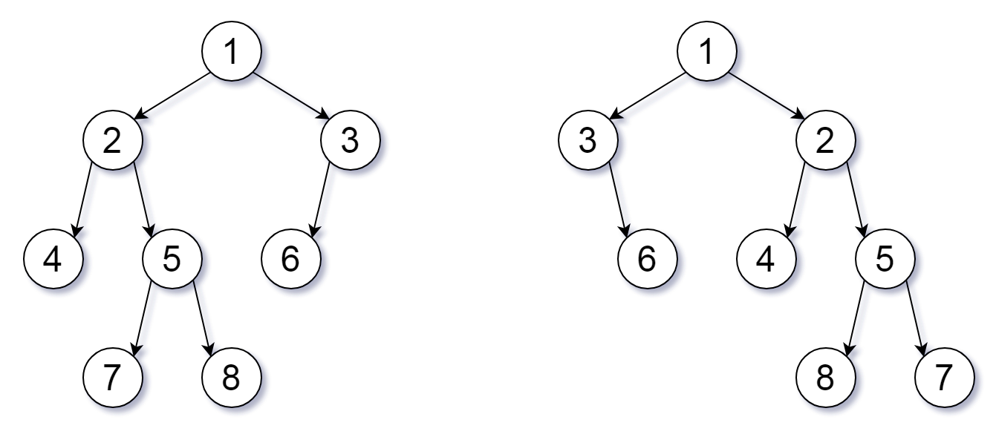

**Input:** root1 = [1,2,3,4,5,6,null,null,null,7,8], root2 = [1,3,2,null,6,4,5,null,null,null,null,8,7]

**Output:** true

**Explanation:** We flipped at nodes with values 1, 3, and 5.

**Example 2:**

**Input:** root1 = [], root2 = []

**Output:** true

**Example 3:**

**Input:** root1 = [], root2 = [1]

**Output:** false

**Example 4:**

**Input:** root1 = [0,null,1], root2 = []

**Output:** false

**Example 5:**

**Input:** root1 = [0,null,1], root2 = [0,1]

**Output:** true

**Constraints:**

* The number of nodes in each tree is in the range [0, 100].
* Each tree will have **unique node values** in the range [0, 99].